
NAME: BISMA FATIMA
CLASS: CS A
ROLL NO: F24605036
COURSE: INFORMATION SECURITY
COURSE CODE: CS-291
LECTURER: MISS ATTIA ASHRAF

LAB 05

Part 1: Verify OpenSSL Installation
Command : openssl version
- If OpenSSL is installed, the above command will display the version.
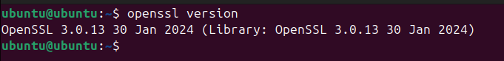

Part 2: Introduction to OpenSSL Command-Line Tools
Commands: openssl help
- The above command will display Standard commands, Message Digest commands and Cipher commands.
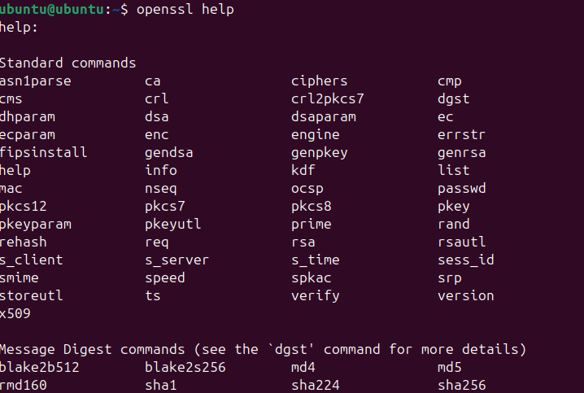

- Information about an individual openssl command
Command: openssl enc -help
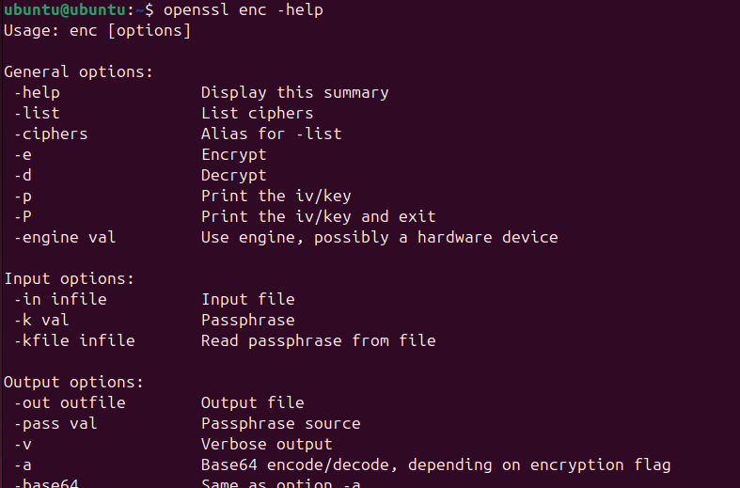

- The detailed information can be found at the corresponding man page
Command: man openssl
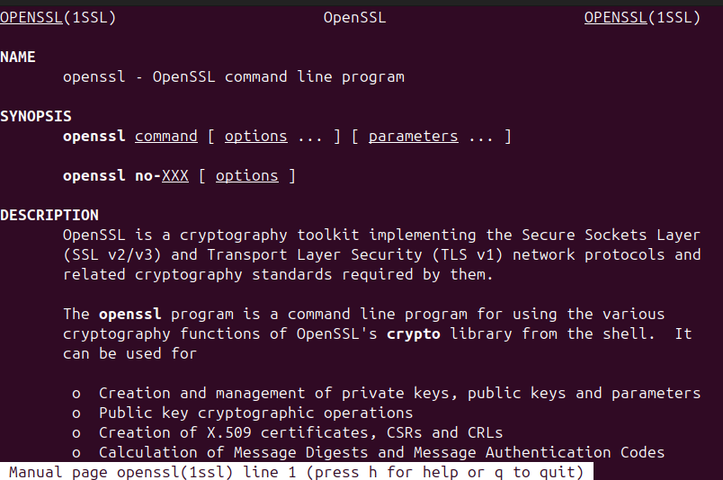

- The different crypto algorithms implemented in your version of OpenSSL
Command: openssl list-cipher-algorithms or with openssl enc -ciphers
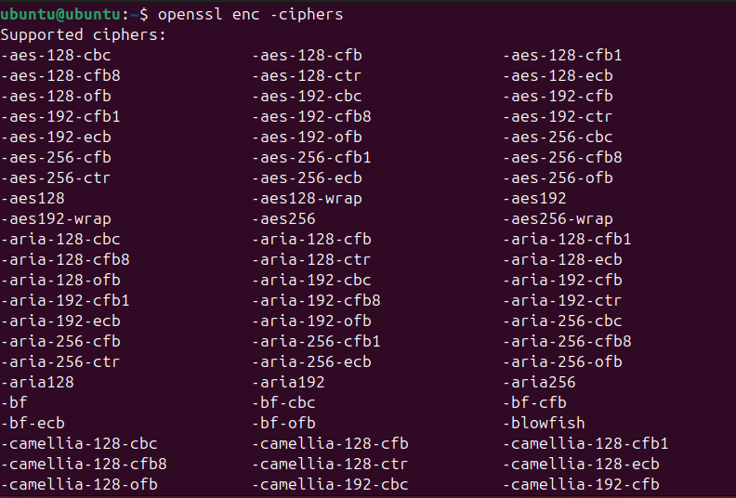

Part 3: Symmetric Encryption Using AES
- Create a File to Encrypt
Command: echo "This is a sample plaintext file for encryption." > plaintext.txt

- Encrypting a File
Command: openssl enc -aes-256-cbc -pbkdf2 -in plaintext.txt -out encrypted.txt
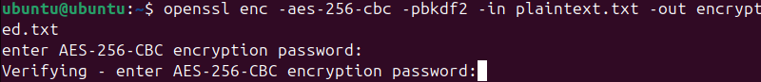

- Encrypted file
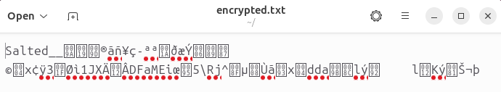

- Decrypting a File
Command: openssl enc -aes-256-cbc -d -pbkdf2 -in encrypted.txt -out decrypted.txt
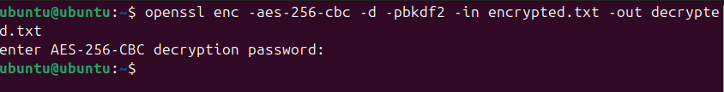
- Decrypted file
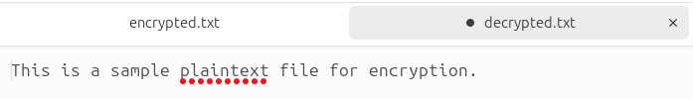

- Verification
Command: cat decrypted.txt
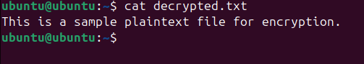

Part 4: Asymmetric Key Generation Using RSA
- Generate an RSA Private Key
Command: openssl genpkey -algorithm RSA -out private_key.pem -pkeyopt rsa_keygen_bits:2048
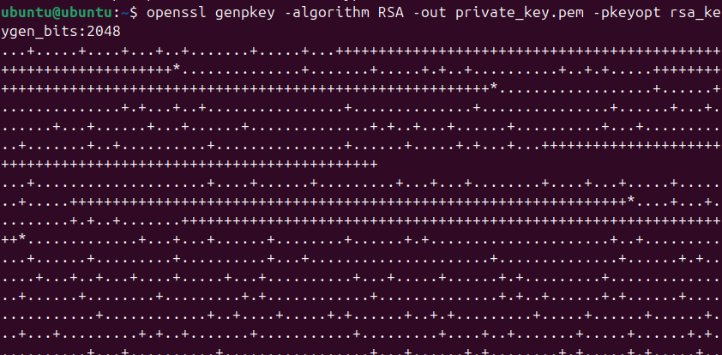

- Extract the Public Key
command: openssl rsa -in private_key.pem -pubout -out public_key.pem
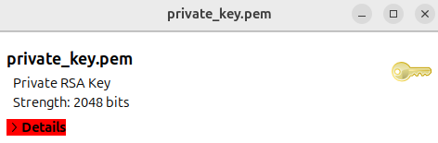

Part 5: Encrypting and Decrypting Using RSA
- Encrypting with the Public Key
Command: openssl pkeyutl -encrypt -in plaintext.txt -inkey public_key.pem -pubin -out encrypted_rsa.txt
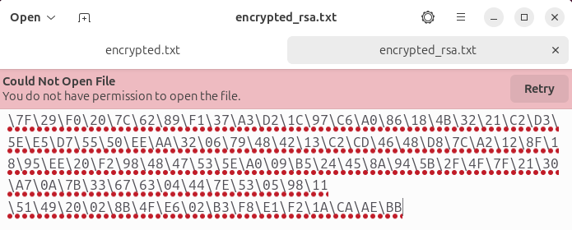

- Decrypting with the Private Key
Command: openssl pkeyutl -decrypt -in encrypted_rsa.txt -inkey private_key.pem -out decrypted_rsa.txt
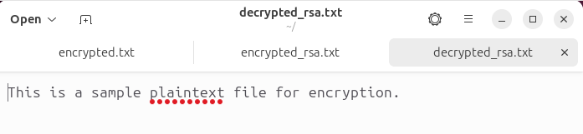
Verification
Command: cat decrypted_rsa.txt
